# Steps for publishing samples in GitHub

Once samples have been compiled successfully we need to publish this samples to GitHub. Follow the below steps to publish the samples on GitHub

1. We can create a local Git repository using below command. Navigate to the source directory need to be published and run this command in command line

- git init

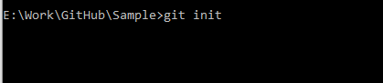

2. After that we need to add all the files to the above created repository.

- git add .



3. Then we need to commit the files to Git using below command

- git commit -m "files added"

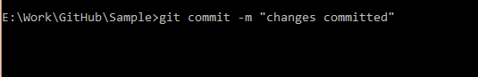

4. Then we need to create a GitHub account and create a repository there.

**Ex:** <https://github.com/balajirenganathan/Samples_Demo.git>

account - balajirenganathan

repository name - Samples_Demo

5. Add the committed projects in the local repository (in step 3) to the GitHub repository created above by using the following command.

- git remote add origin <https://github.com/balajirenganathan/Samples_Demo.git>



6. Finally we need to push the changes by using below command to push the changes to GitHub repository.

- git push -u origin master

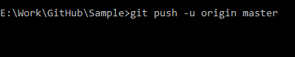

By doing the above steps, we can host our local files in a GitHub repository.

<https://github.com/balajirenganathan/Samples_Demo>

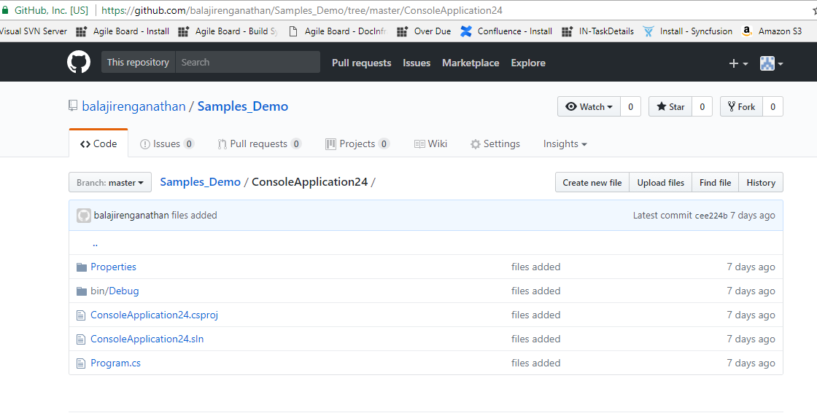

Refer below article for more information regarding publishing files in GitHub repository.

<https://wpism.com/publish-local-project-github-command-line/>